Training Services Australia

Introduction to Training Packages

Introduction
Welcome to Training Services Australia’s ‘Introduction to Training Packages’ module.
The ability to access and use Training Packages is essential for:
- All trainers and assessors who are working within the national training system.
- All people undertaking the Certificate IV in Training and Assessment (TAE40110).
This module has been designed to assist you in this regard, and should be completed before attending any of the following TSA courses.
- Introduction to VET  - Design and develop assessment tools | - Workplace assessment  - Design and deliver training

Please note: This module is aimed at people who have little or no familiarity with Training Packages and the Training.gov.au website. Experienced users of Training Packages and Training.gov.au are not required to complete the module. If you have already completed the module as part of your preparation for another TSA course, you do not need to do it again.
The estimated timeframe for completing this module is 30 to 60 minutes. You will also require:
- Access to the internet
- Basic computer knowledge (including use of the internet to search for information)
Access to a printer will also be useful but is not essential.
If you do not have internet access, or are having trouble completing any part of this module, please contact Training Services Australia on 08 9422 6444 or tsa@tsa-wa.com.au.

Module overview / design
This module has been designed to help introduce you to Nationally Recognised Training Packages and to support you to use ‘Training.gov.au’ to find a Training Package which links to your background / experience.
The module is broken into four parts:
- What is a Training Package?
- How to find a Training Package
- How to find the Packaging Rules for a Qualification
- How to find a Unit of Competency

Please note:
This module has been designed to give you introductory exposure to Training Packages, qualifications, units of competency and the ‘training.gov.au’ website.
Do not get too concerned if, after completing this module, you do not feel that you have a complete understanding of how Training Packages or units of competency work. You will be given an opportunity to explore these further with your facilitator and other learners during the training workshop.

The ‘training.gov.au’ website is updated from time to time.
Training Services Australia will endeavour to make adjustments to this module as required to keep pace with changes to the ‘training.gov.au’ website.
If you believe the module you are using is out of date, you may wish to check the Training Services Australia website (www.tsa-wa.com.au) to ensure you have the latest version. Instructions for downloading the latest version of this module are as follows:
- Go to the TSA website (www.tsa-wa.com.au)
- Select ‘Downloads’ from the menu at the top of the screen
- Select ‘TAE Course Downloads’
- Select ‘Introduction to Training Packages module’ from the bottom of the menu

Part 1 – What is a Training Package?
In the Vocational Education and Training (VET) sector in Australia, a Training Package is a set of nationally endorsed qualifications and competency standards which address the skills and knowledge people need to perform effectively in the workplace.

Training Package components
All Training Packages contain endorsed components. These are the parts of the Training Package that are formally recognised by the government body responsible for quality assurance of the VET sector. Training Package endorsed components include:
- Units of Competency: These are descriptions of the specific skills and knowledge needed by individuals to perform a job to the standard expected in the workplace. Units of competency are also known as competency standards.
- Assessment Guidelines / Assessment Requirements: These set out the type of evidence required to confirm an individual’s competency and how assessment should be conducted.
- Qualifications: Each Training Package contains a number of qualifications, made up of different units of competency. For each qualification, there are rules about the number and of combination of units required.
As part of this module we will show you how to access Units of Competency, Assessment Requirements and Qualifications. We will provide you with more information on Assessment Guidelines as part of your training.
Note: Many people find the term ‘Training Package’ quite misleading because Training Packages do not contain training resources such as training plans, workbooks, manuals, PowerPoint presentations, training handouts, etc.
Instead they contain:
- Sets of industry standards (units of competency)
- Rules for how the standards can be combined to make up qualifications
- Information about how those standards should be assessed

Part 2 – How to find a Training Package
Training Packages can be accessed from Training.gov.au (TGA).
TGA is the official National Register of information on Training Packages, Qualifications, Courses, Units of Competency and Registered Training Organisations (RTOs).
Instructions
Please follow the instructions below to find a Training Package relevant to your industry / background / experience.
2.1 Access the Training.gov.au (TGA) website using the following URL – http://training.gov.au/home/Tga
2.2 Go to the ‘Quick search’ box and click on the ‘Search’ button for Nationally recognised training (leave the search box blank).
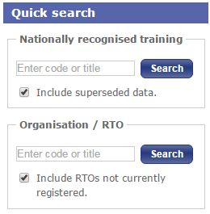
2.3 In the ‘Nationally recognised training search’ screen tick the ‘Training Packages’ box and click on the ‘Search’ button (make sure all other boxes are unticked, including the ‘Include superseded / expired data’ box)
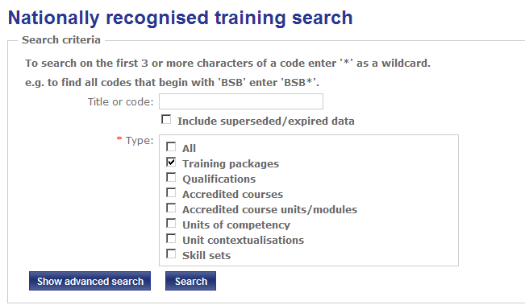
2.4 To view a list of all current Training Packages, change the number of ‘Items per page’ from 10 to 100. There should be about seventy current Training Packages listed
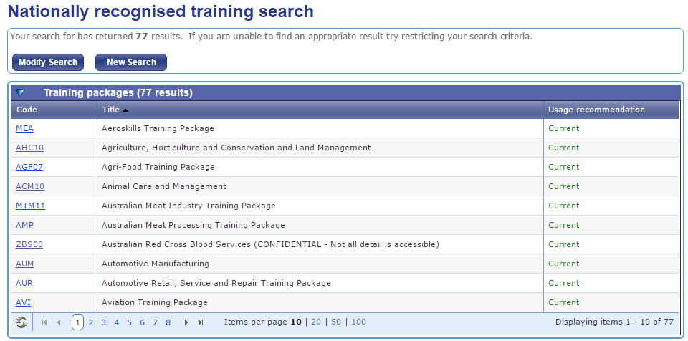
2.5 Search through the list of Training Packages until you find one which is relevant to your industry / background / experience. You may discover that some industries include more than one Training Package. The reasons for this will be explained during the training workshop.
Your Industry / Experience |  | Possible relevant Training Package
Examples | Mining | RII – Resources and Infrastructure
 | Public service | PSP – Public Sector
 | Health | HLT – Health
 | Community Services | CHC – Community Services
 | Oil and Gas | PMA08 / PMA – Chemical, Hydrocarbons and Refining
 | Transport and Logistics (including Rail) | TLI – Transport and Logistics
2.6 Click on the link to the Training Package you have selected.
2.7 Read through the Training Package details. In particular, pay attention to:
(a) The Training Package version (under ‘Releases’)
(c) The following Training Package components:
- Qualifications
- Skill Sets
- Units of competency

Part 3 – How to find the Packaging Rules for a Qualification
The Packaging Rules for a Qualification describe the units that need to be completed to obtain the qualification.
Instructions
Please follow the instructions below to find a qualification relevant to your industry / background / experience, or one that you are interested in.
3.1 Click on the link to a qualification from the Training Package you have selected
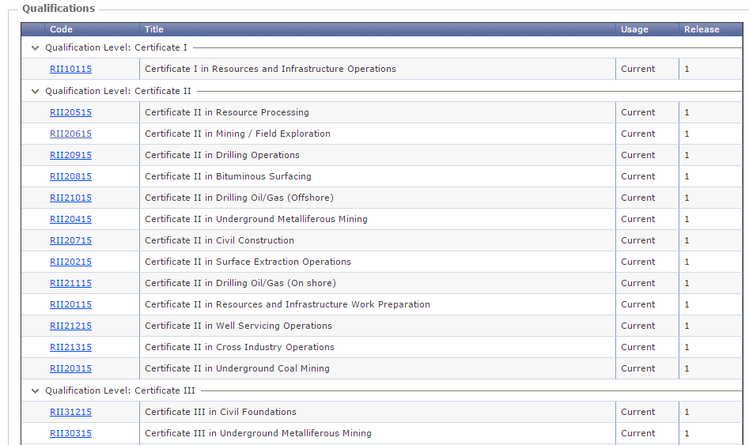
3.2 Scroll down the page and you will find information about the qualification under the heading “Modification History”.
3.3 Read through the qualification information, and in particular, the Entry Requirements and Packaging Rules sections which provide information about what is required to achieve the qualification. Pay attention to:
(a) The total number of units
(b) The number of core and elective units
3.4 Select a unit which you would like to find out more about and note down the code and title of the unit.
For example:
Code | Title
RIIWHS201D | Work safely and follow WHS policies and procedures

Part 4 – How to find a Unit of Competency
Units of competency (also known as competency standards) define the outcomes required for competent performance within a particular area of work or work function.
For example, the TAE10 (Training and Education) Training Package is designed for people working in the VET sector, and contains units relating to areas such as:
● Training individuals | ● Planning assessments
● Training groups of people | ● Designing assessment tools
● Developing training programs | ● Conducting assessments
The Retail Services Training Package (SIR) contains units relating to areas such as:
● Ordering stock | ● Customer service
● Store security | ● Safe work practices
● Merchandise presentation | ● Operating point of sale equipment
Instructions
Please follow the instructions below to find a unit of competency relevant to your industry / background / experience, or one that you are interested in.
  - Return to the training.gov.au home page (http://training.gov.au/Home/Tga)
  - In the ‘Quick Search’ box at the bottom of the page, enter the code or title of the unit you selected in step 3.4 (above) and click on the ‘Search button’.
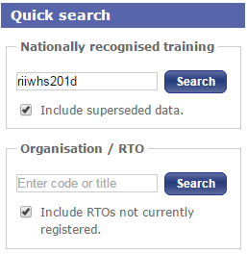
  - A screen will appear showing the unit code and title. To review the unit, you will need to scroll down towards the bottom of the page. Details about the unit can be found under the heading “Unit of competency”
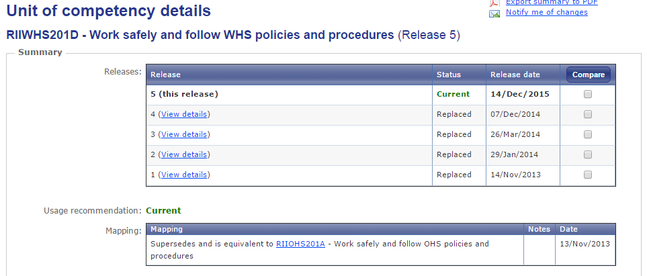
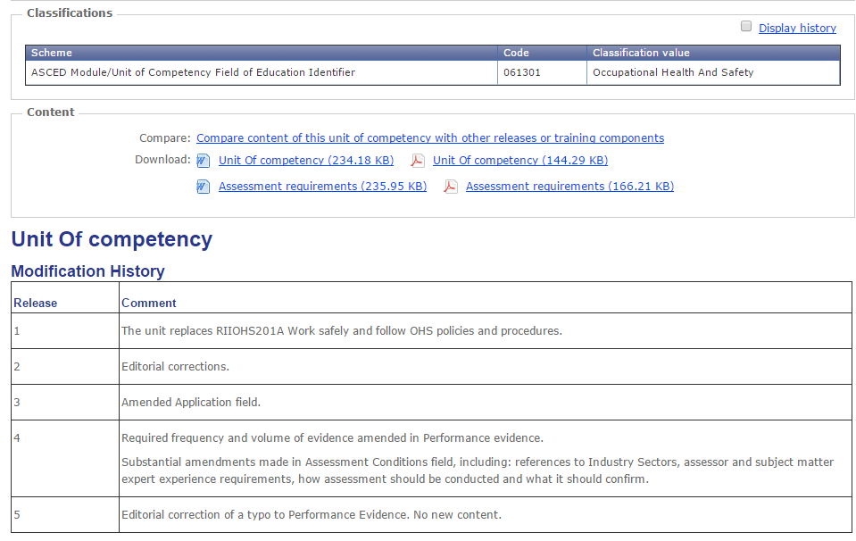
4.4 Units of competency may be presented in one of two formats, depending on how recently they were developed.
The information provided below will help you to identify the key components of a unit of competency and determine whether the unit has been written in the latest format.
Read through the unit of competency you have selected and from the list below, decide which format it has been written in.
Latest format | Older style format
Part 1 – Unit of competency  ☐ Modification history  ☐ Application  ☐ Pre-requisites (where applicable)  ☐ Elements and performance criteria  ☐ Foundation skills  ☐ Unit mapping  Part 2 – Assessment requirements  ☐ Performance evidence  ☐ Knowledge evidence  ☐ Assessment conditions | Unit of competency  ☐ Modification history  ☐ Unit descriptor  ☐ Application of the unit  ☐ Licensing / Regulatory Information  ☐ Pre-requisites  ☐ Employability skills information  ☐ Elements and performance criteria  ☐ Required skills and knowledge  ☐ Evidence guide  - Overview of assessment  - Critical aspects for assessment  - Context of and specific resources for assessment  - Method of assessment  - Guidance information for assessment  ☐ Range statement
☐ I have selected this type of unit | ☐ I have selected type of unit

Consider the unit of competency you have just reviewed.
- If you were designing training sessions based on this unit, what information would be most useful?

- If you were going to design an assessment for this unit, what information would be most useful?

4.5 Printing – To print a copy of the unit of competency, please follow the instructions below:
Above “Unit of competency” you will see a “Content” box.
For units written in the latest format, you need to download and print the unit of competency as well as the assessment requirements (print in Word or PDF).
For units written in the older style format, you just need to download and print the unit of competency (print in Word or PDF).

Older style format
Only the unit of competency is displayed.
Download and print this

Latest format
The unit of competency and assessment requirements are displayed.
Download and print both

Conclusion
Congratulations on completing this ‘Introduction to Training Packages’ module.
Do not be too concerned if you do not feel that you have a complete understanding of how Training Packages or units of competency work. You will be given an opportunity to explore these further with your facilitator and other learners during the training workshop.

